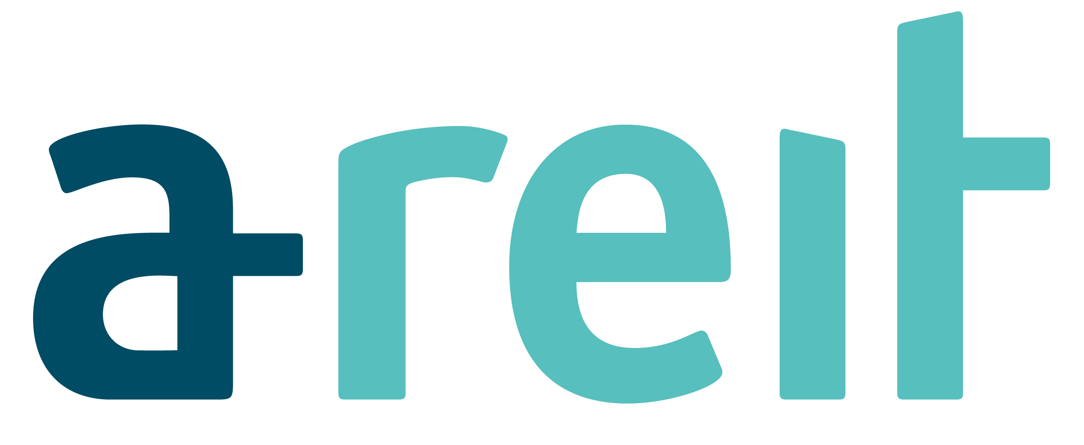

Issue of Units to Manager in lieu of Management Fees

8 June 2003, Singapore – The Board of Directors of Ascendas-MGM Funds Management Limited (”Ascendas-MGM”) wishes to announce that 746,077 units in Ascendas Real Estate Investment Trust (“A-REIT”) (“Units”) have been issued to Ascendas-MGM, in its capacity as manager of A-REIT. The Units were allotted at an issue price of S$1.4347 per Unit, in lieu of the payment of 50% of the Base Fee component of the management fee for the period 19 November 2003 to 18 May 2004.

The Base Fee is defined in the trust deed constituting A-REIT (the “Trust Deed”) as 0.5% per annum of the value of all the gross assets of A-REIT. In accordance with the Trust Deed, the issue price was determined based on the volume weighted average traded price for a unit for all trades done on Singapore Exchange Securities Trading Limited (“SGX-ST”) in the ordinary course of trading on the SGX-ST for 10 business days immediately preceding the date of issue of Units to Ascendas-MGM.

This mode of paying 50% of the Base Fee in Units was disclosed in the section entitled “The Manager and the Sponsors” on page 125 of the prospectus dated 5 November 2002 issued in connection with the initial public offering of units.

Following the above issue of Units, the total A-REIT units on issue is 709,525,633 of which Ascendas-MGM’s holding is 4,281,709 units.

By Order of the Board
Ascendas-MGM Funds Management Limited
as manager of Ascendas Real Estate Investment Trust

Tay Hsiu Chieh
Company Secretary
8 June 2004

